Overview:

* Throw in percentage 68.9% decrease from average 83.7% | Opp Throw ins was 92.86%
* Duels decreased by 5% from Lipscomb
  + Defensive duels was lowest all season at 49%
  + Duels lost were in the center of the field while duels won were on the flanks
  + Left side won 41.66% of defensive duels | Right side won 48% of defensive duels
  + Highest Winning Players: James, Cole, Adam
  + Offensive duels was highest all season at 46.8%
  + Left side won 55.2% of their duels | Right side won 44.2% of their duels
  + Highest Winning Players: Quinn, Jonah, McGee
* Forward pass accuracy was 64.62% a 5% drop from Lipscomb second lowest this season
  + 6% more passes on the right side
  + Right side was 10% more accurate
  + Only 5 deep completed passes
  + Highest Accuracy Players: Adam, Jonah
* 75% of USD’s shots were outside of the penalty area and only 26% of those were on frame.

Possession is labeled as the percent when the player has the ball keeps UCSD in possession (Passes + Offensive duels)

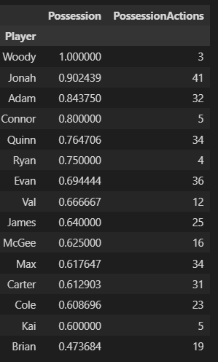

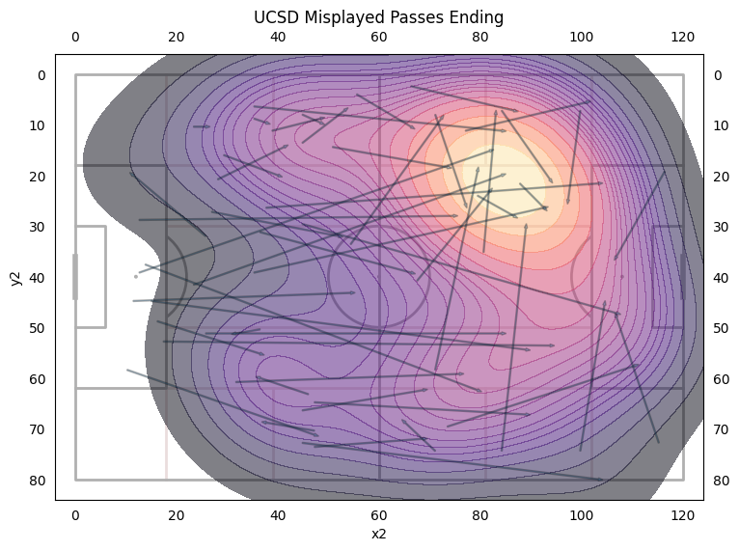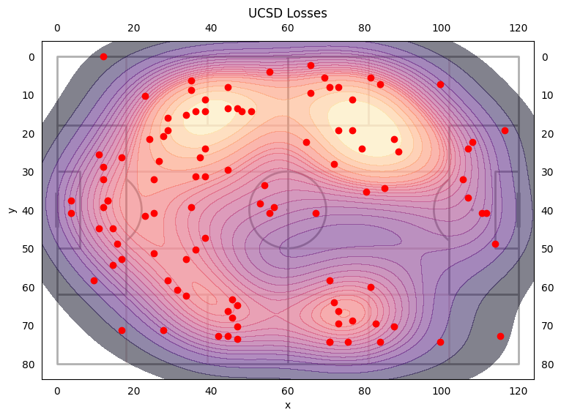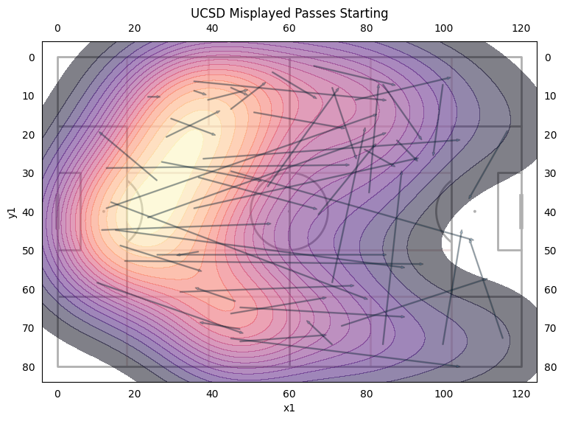

* Most of our losses were in U shape from the left flank to defensive third to right flank
* Left flank had more losses than the right flank.
* 51.4% of losses were duels | 48.6% of losses were misplaced passes
* Most losses came from Evan with 14, then Carter, Nolan, and Max at 11, Then Adam at 9.
* Defensive Duel win rate was 49.3% the lowest this season by 8% and current season average is 60.7%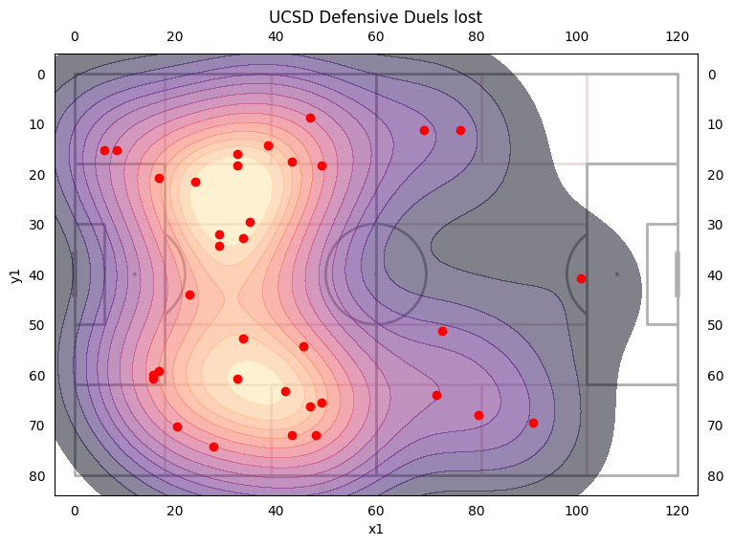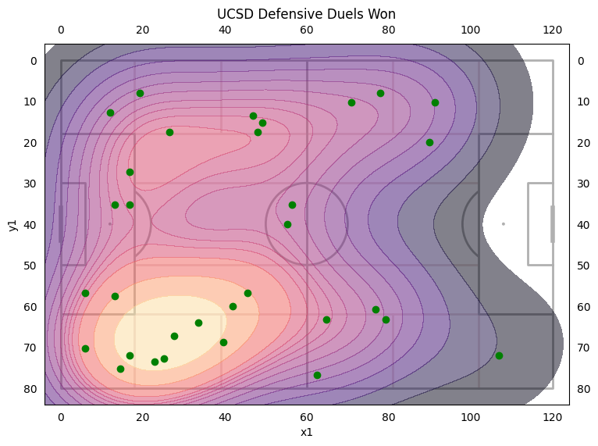
* Only won 45.1% of duels in our own half
  + Left side won 41.66%
  + Right side won 48.1%
* Highest Winning Players: James (80%), Cole (75%), Adam (67%).
* Lowest Winning Players: Brian (33%), Max (25%), Evan and Woody (33%)
* Offensive Duel win rate was 46.88% the highest this season by 5% current season average is 37.1%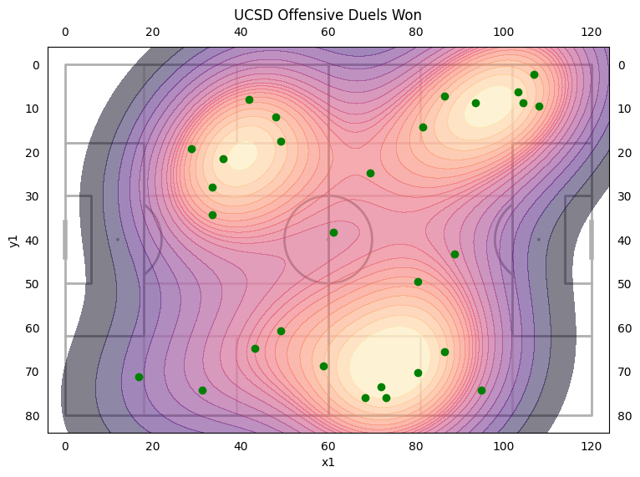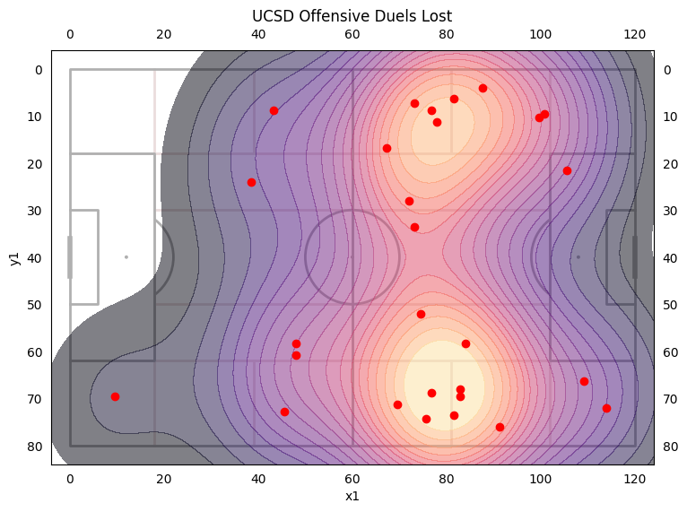
  + Left side won 55.2% of duels
  + Right side won 45% of duels
* Players with most duels: Max with 12 (50%), Brian with 11 (18%), Quinn with 7 (100%), Cole with 6 (33%), McGee (75%) and Val (0%) at 4
* Highest Winning Players: Quinn (100%), Jonah (100%), McGee (75%)
* Lowest Winning Players: Brian (18%), Val (0%), Cole (33%)
* Forward Passing Accuracy of 64.62% a 5% decrease from Lipscomb and second lowest this season (Duke was lowest)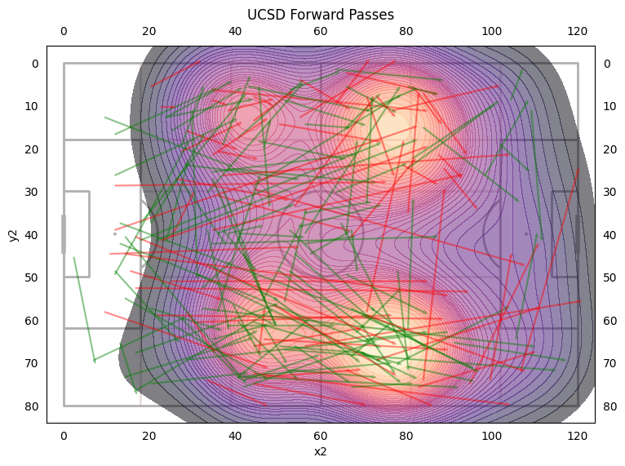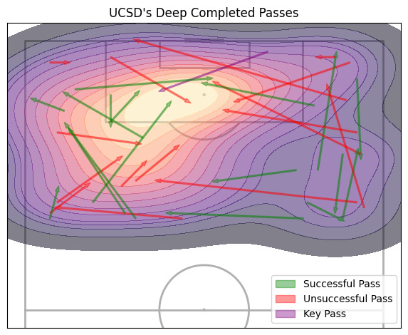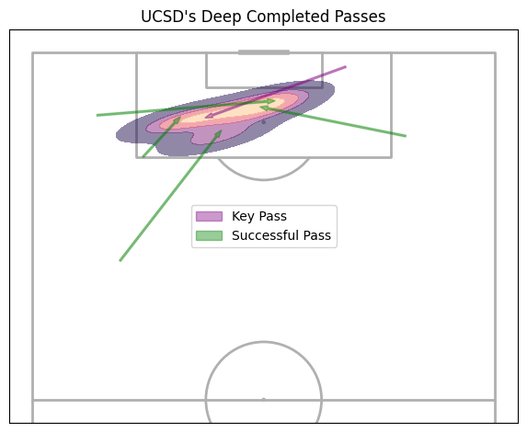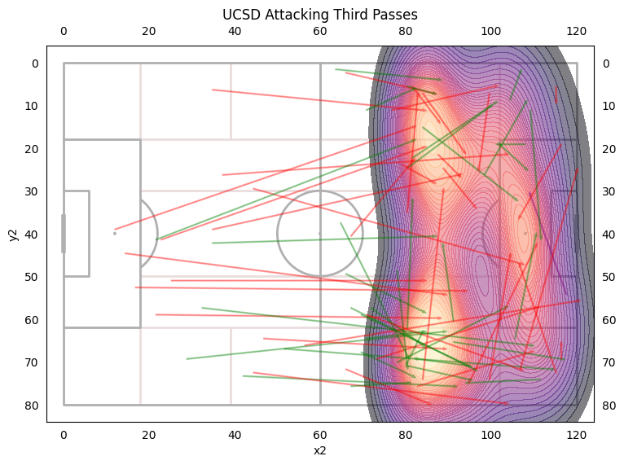
* 37.6% of passes were on the left, 43.2% of passes were on the right, 19% of passes were switch
* The left side was 64.5% accurate, the right side was 75.4% accurate, switches were 82% accurate.
* Only 5 Deep Completed Passes

Player Passes

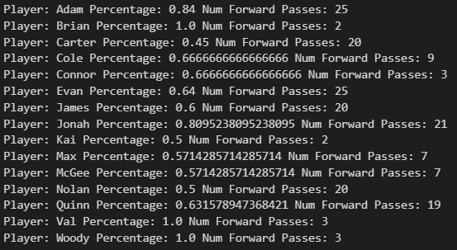

Highest Accuracy Players: Adam (84%), Jonah (80.9%)

Lowest Accuracy Players: Carter (45%), Nolan (50%)

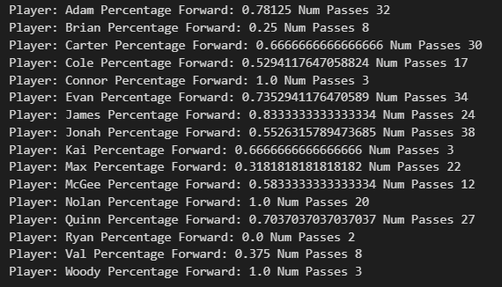

Players that Play Forward the Most: James (83%), Adam (78%), Evan (73.5%), Quinn (70.3%)

Players that Play Forward the Least: Brian (25%), Val (37.5%), Max (31.8%)

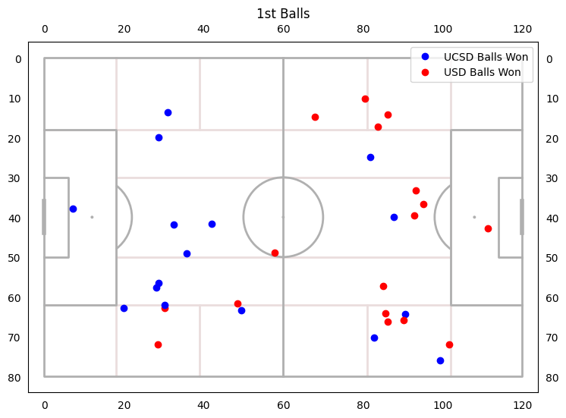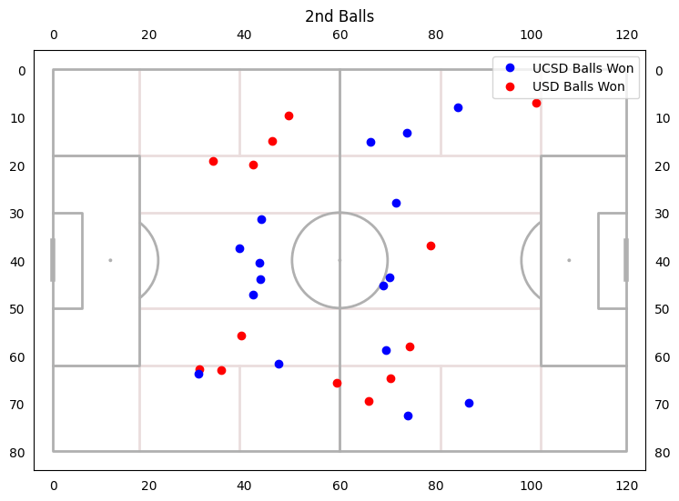

* 1st Ball Win Rate: 48.4%
* 2nd Ball Win Rate: 44.8%
  + 2nd ball win rate if we won the first ball was 51%
  + 2nd ball win rate if we lost the first ball was 40%

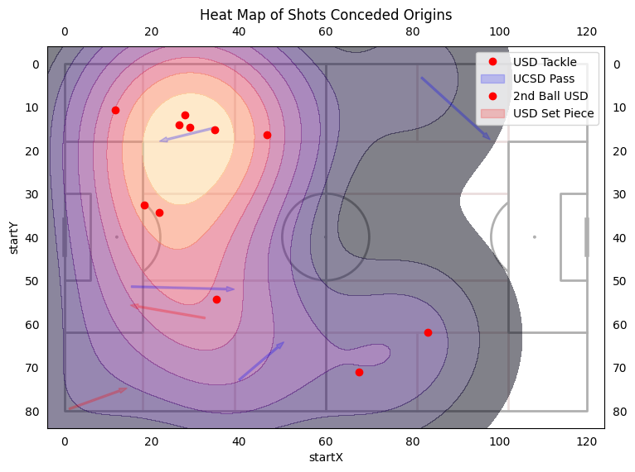

Chance Origins

Opponents Chances

* 23.5% of opponents chances came off a misplayed pass
* 11.8% came off of set pieces
* 23.5% came off of second balls won by USD
* 41.2% came off of tackles

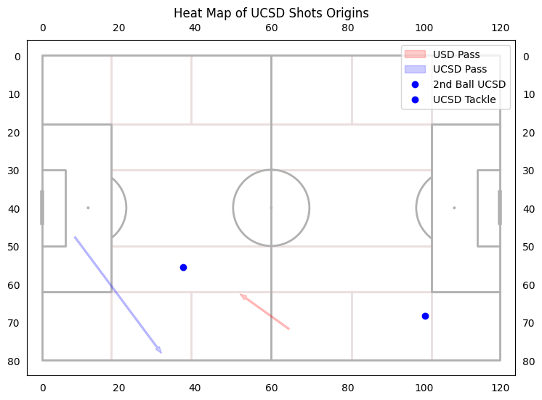

UCSD Chances

* 1 chance off misplayed USD Pass
* 1 chance off Nolan’s distribution
* 1 chance off 2nd ball UCSD
* 1 Chance off Tackle